**Frontend Test (Advanced)**

(This exercise uses the result of Chapter 7 Test)

1. **Create a new frontend page**

* Create a new page in frontend that has Magento Layout, page’s url: http://<magento_baseurl>/<module_route>
* Add a button to the content of this page, e.g:

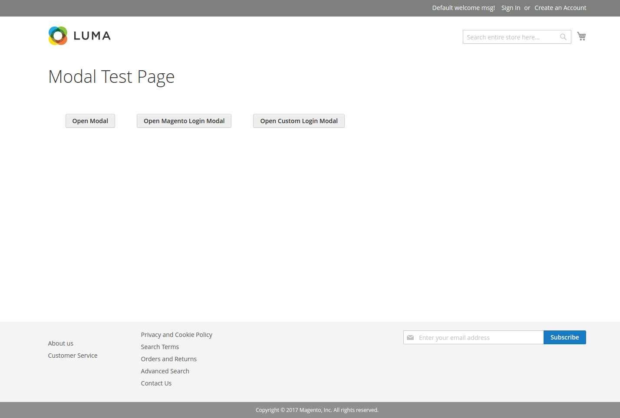

1. **Using RequireJS**

* Learn how to use RequireJS, load out “jquery” library (already in Magento)
* Whenever the button created above clicked, alert “Hello World!”
* Now that the alert works, delete it. Use “magento alert modal” instead, find out how to use “magento alert modal”
* Create a 2nd button. Whenever clicked, a **Modal** (a concept in magento, simply it’s a popup javascript window) is drop downed.
  + This Modal contain: a login window, e.g: (notice: you can style it yourself)

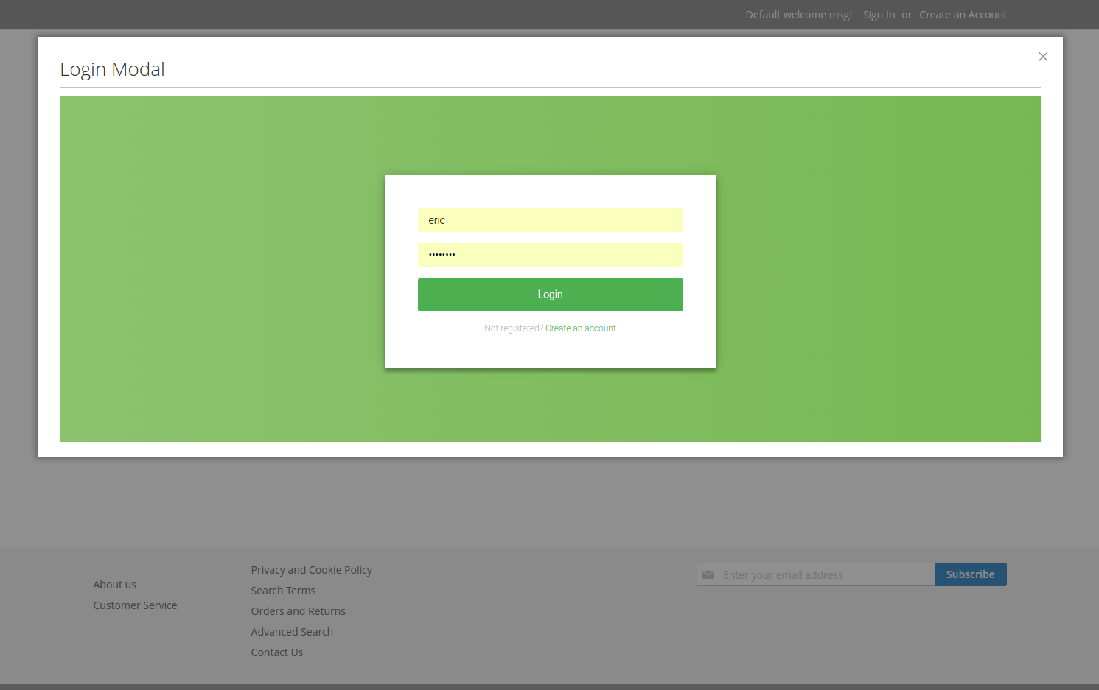

(Checkout this page(not always available): <http://192.168.0.116/m217dev/test/modal> , click on “Open Modal” button)

1. **Knockout JS**

(Knockout Js (KO) is an important aspect in Magento, KO is a js library that is used widely, in almost every page in Magento)

* Read an Overview about KnockoutJs, finish all the tutorial: <http://knockoutjs.com/>
* Read this article about Knockout JS in Magento, written by a Magenest’s developer: <http://magenest.com/how-to-use-knockout-js-on-a-magento-2-frontend-page/>